ELEG 309 - Example Problems Chapter 7-2

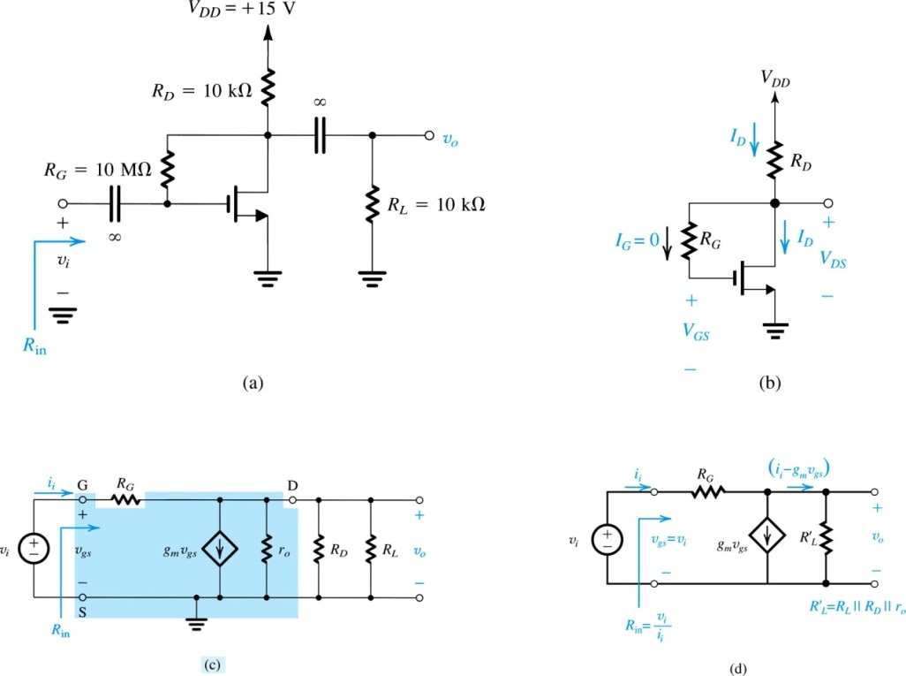**Example 7.3**

Figure 7.15(a) shows a discrete common-source MOSFET amplifier utilizing a drain-to-gate resistance *RG* for biasing purposes. Such a biasing arrangement will be studied in Section 7.4. The input signal *vi* is coupled to the gate via a large capacitor, and the output signal at the drain is coupled to the load resistance *RL* via another large capacitor. We wish to analyze this amplifier circuit to determine its small-signal voltage gain, its input resistance, and the largest allowable input signal. The transistor has *Vt* = 1.5 V, *k’n*(*W/L*) = 0.25 mA/V2*,* and *VA* = 50 V. Assume the coupling capacitors to be sufficiently large so as to act as short circuits at the signal frequencies of interest.

**Figure 7.15 Example 7.3:** (a) amplifier circuit;

.

1) DC Operating (Q) point



2) Small Signal Analysis

**Example 7.4**

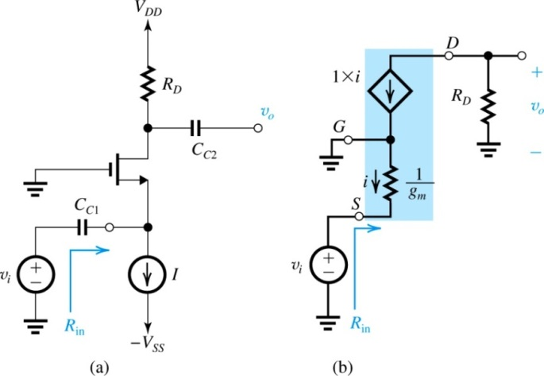Figure 7.18(a) shows a MOSFET amplifier biased by a constant-current source *I*. Assume that the values of *I* and *RD* are such that that the MOSFET operates in the saturation region. The input signal *vi* is coupled to the source terminal by utilizing a large capacitor *CC*1. Similarly, the output signal at the drain is taken through a large coupling capacitor *CC*2. Find the input resistance *Rin* and the voltage gain *vo*/*vi*. Neglect channel-length modulation.

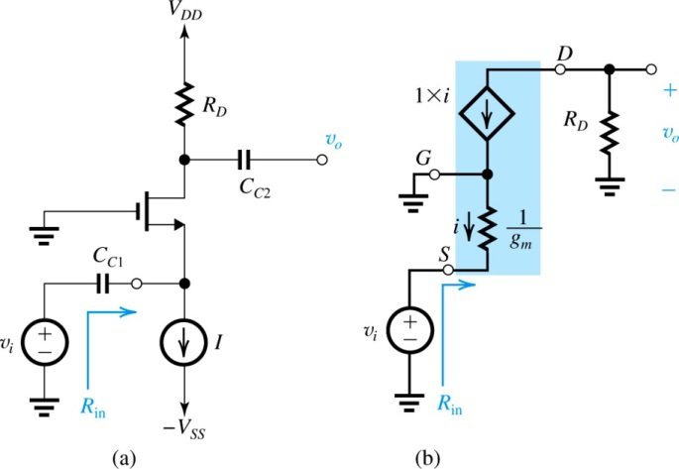

**Example 7.5**

We wish to analyze the transistor amplifier shown in Fig. 7.28(a) to determine its voltage gain *vo*/*vin*. Assume ** = 100 and neglect the Early effect.

